Product Requirements Document Identity & Access Control for RACKAI Platform

Table of Contents
Product Requirements Document Identity & Access Control for RACKAI Platform 0
1. Vision 3
RBAC should ensure: 3
What this means in practice 3
Outcome 3
2. Problem Statement 4
The Challenge 4
Impact 5
Conclusion 5
3. Product Principles 5
4. Scope 6
In Scope 6
Out of Scope 6
5. Core Entities 7
User 8
Service Identity (API Key / Token) 8
Role 8
Permission 8
Resource 8
Tenant 8
Project 8
6. Identity & Authentication Model 9
Identity Propagation 10
7. Access Model 10
Permission Source of Truth 10
Role Assignment 10
Role Assignment Rules 10
Permission Structure 10
8. Default Roles 11
Admin 11
ML Engineer 11
Developer 11
Viewer 11
Billing Admin 11
Role Scope 11
Custom Roles (Future) 12
9. Permission Model 12
Core Permission Categories 12
Permission Scope 12
Permission Evaluation 12
10. Request Authorization Flow 12
11. API Access Control 13
12. Integration with Platform 13
13. Audit & Logging 14
14. Failure Handling 14
Security-First Behavior 14
Failure Scenarios & Expected Behavior 14
Consistency & Recovery 15
Audit & Observability 15
Operational Guarantees 15
15. Success Criteria 16
16. Summary 16

1. Vision
Enable tenants to securely manage access to models, data, and platform capabilities through a flexible, scalable, and centrally enforced access control system.
The RBAC system should provide a consistent and reliable way to:
- define who can access which resources
- control what actions users can perform
- enforce access policies across all services and APIs

RBAC should ensure:
- Strict isolation between tenants
Prevent any cross-tenant visibility or interaction.
- Fine-grained control within a tenant
Roles and permissions can be applied at tenant, project, and resource levels.
- Consistent enforcement across the platform
Applies to:
  - inference & training workloads
  - metering & billing APIs
  - quota & configuration systems
  - datasets, secrets, observability
- Scalability with tenant growth
Supports increasing users, roles, and workloads without degradation.

What this means in practice
Access control should feel:
- Secure – no unauthorized access
- Predictable – consistent permission behavior
- Easy to manage – simple defaults + flexible extensions
- Transparent & auditable – all actions traceable

Outcome
RBAC enables tenants to:
- collaborate safely
- control access to critical resources
- meet compliance requirements
- scale usage with governance
Every action is not only measured and billed—but also authorized and controlled.
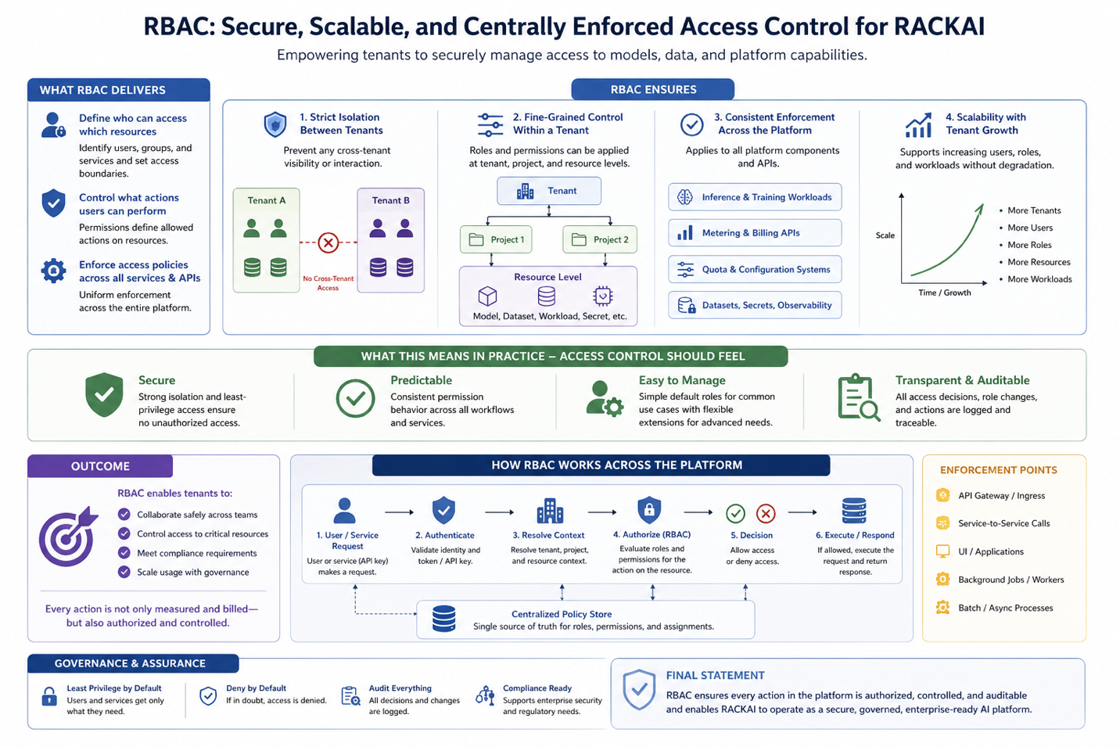

2. Problem Statement
As RACKAI scales, each tenant includes multiple users:
- developers
- ML engineers
- platform admins
- viewers
- billing admins
Each role requires different access to:
- models
- workloads
- datasets
- usage & billing data

The Challenge
Without RBAC:
- unintended access to sensitive resources
- inconsistent enforcement across services
- increased operational and security risk
- inability to meet compliance requirements

Impact
- reduced platform trust
- higher operational overhead
- increased risk of security incidents
- blocked enterprise adoption

Conclusion
RACKAI requires a centralized, consistent, and auditable RBAC system.

3. Product Principles
- Least Privilege by Default
- Tenant Isolation
- Consistency Across the Platform
- Explicit and Auditable Access
- Simple to Use, Powerful to Extend
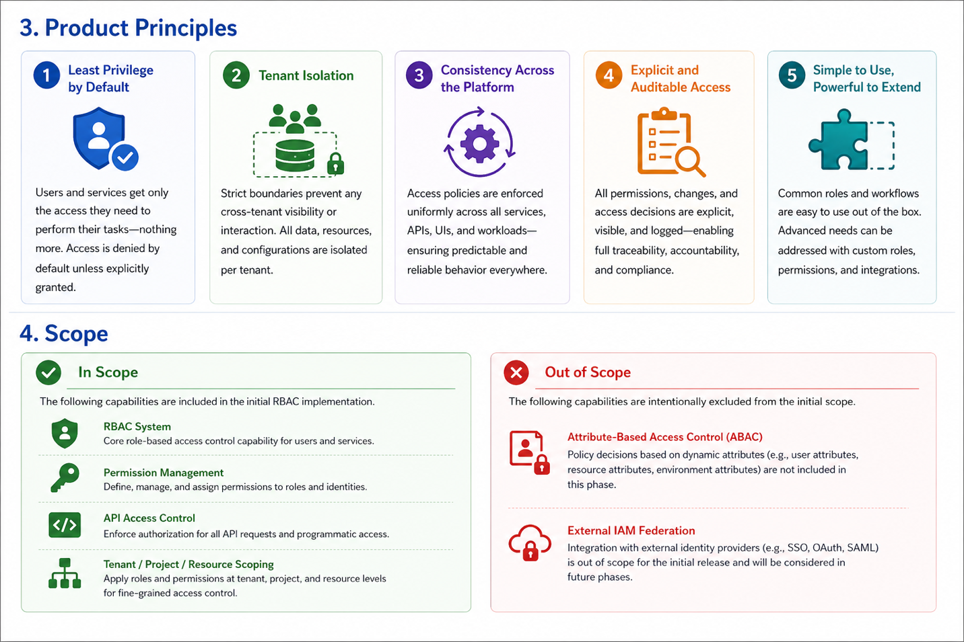

4. Scope

In Scope
- RBAC system
- permission management
- API access control
- tenant/project/resource scoping

Out of Scope
- ABAC (future)
- external IAM federation (future)

5. Core Entities
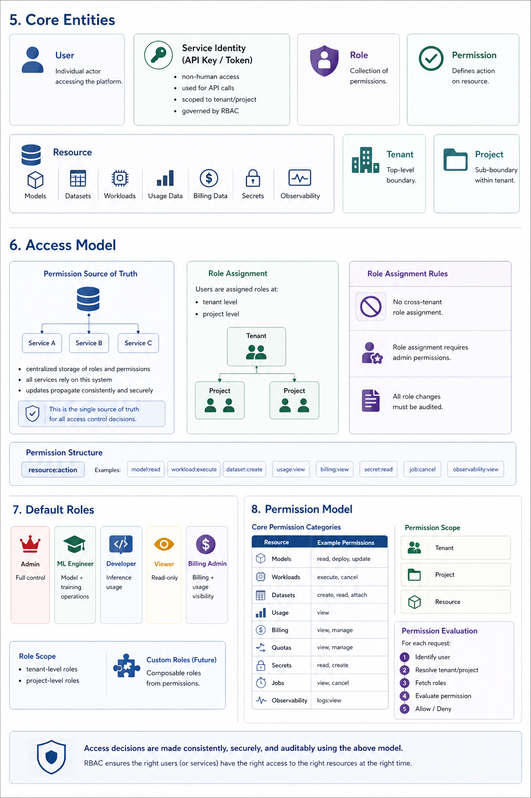

User
Individual actor accessing the platform

Service Identity (API Key / Token)
- non-human access
- used for API calls
- scoped to tenant/project
- governed by RBAC
Identity Uniqueness
• identities must be globally unique within the system and consistently resolvable across the platform.

Role
Collection of permissions

Permission
Defines action on resource

Resource
- models
- datasets
- workloads
- usage data
- billing data
- secrets
- observability

Tenant
Top-level boundary

Project
Sub-boundary within tenant
Dataset / Fine-Tuning Data
- data uploaded by tenants for fine-tuning jobs
- scoped to tenant and project
- must be access-controlled independently of models

6. Identity & Authentication Model
All requests to the platform must be authenticated and associated with a verified identity.
The platform supports:
  - User identities (human users via identity provider)
  - Service identities (API keys / tokens for programmatic access)

Authentication is responsible for:
- validating the identity of the caller
- establishing tenant and project context
- providing identity metadata to downstream systems

Each authenticated request must include:
  - user_id or service_id
  - tenant_id
  - project_id (if applicable)

This context is used by:
  - RBAC → authorization decisions
  - Metering → usage attribution
  - Observability → logging and audit

Authentication must be enforced before any authorization or execution occurs.
Token & API Key Model
- Authentication must support:
  - JWT tokens for user authentication
  - API keys for service authentication

Tokens and API keys must:
  - be scoped to a tenant (and optionally project)
  - support expiration and rotation
  - be revocable at any time
  - Tokens must include or resolve tenant_id and identity information required for downstream systems.
  - API keys must be securely stored and never exposed in plaintext.

Identity Propagation
Authenticated identity context must be propagated across all services using:
  - request headers or tokens
  - consistent identity fields (user_id, tenant_id, project_id)
All services must rely on this propagated context for authorization, metering, and observability.
Identity context must remain consistent and immutable throughout the request lifecycle once established.

7. Access Model

Permission Source of Truth
- centralized storage of roles and permissions
- all services rely on this system
- updates propagate consistently and securely

Role Assignment
Users are assigned roles at:
- tenant level
- project level

Role Assignment Rules
- no cross-tenant role assignment
- role assignment requires admin permissions
- all role changes must be audited

Permission Structure
resource:action
Examples:
- model:read
- workload:execute
- dataset:create
- usage:view
- billing:view
- secret:read
- job:cancel
- observability:view
- dataset:create
- dataset:read
- dataset:attach
- dataset:delete

8. Default Roles

Admin
Full control

ML Engineer
Model + training operations

Developer
Inference usage

Viewer
Read-only

Billing Admin
Billing + usage visibility

Role Scope
- tenant-level roles
- project-level roles

Custom Roles (Future)
Composable roles from permissions

9. Permission Model

Core Permission Categories
Resource | Example Permissions
Models | read, deploy, update
Workloads | execute, cancel
Datasets | create, read, attach
Usage | view
Billing | view, manage
Quotas | view, manage
Secrets | read, create
Jobs | view, cancel
Observability | logs:view

Permission Scope
- tenant
- project
- resource

Permission Evaluation
For each request:
- identify user
- resolve tenant/project
- fetch roles
- evaluate permission
- allow/deny

10. Request Authorization Flow
- Authentication & Identity Validation
  - validate token or API key
  - verify user or service identity
  - reject unauthenticated requests
- Context Resolution
  - determine tenant_id
  - determine project_id (if applicable)
  - attach identity and tenant context to the request for downstream propagation
- Role Retrieval
  - fetch roles assigned to the identity
- Permission Evaluation
  - check permissions for requested resource and action
- Decision
  - allow or deny request
Authentication verifies identity.
RBAC determines what that identity is allowed to do.

11. API Access Control
- validate identity
- enforce RBAC
- enforce tenant isolation
Authorization Caching
- cache permission checks
- scoped by user + tenant + project

Cache Invalidation
- role changes
- permission updates
- tenant/project changes

Security Requirements
- no stale permissions allowed
- must always reflect latest access

12. Integration with Platform
RBAC integrates with:
- metering → restrict usage data
- quotas → restrict configuration
- billing → control financial visibility
- datasets → control data access
- secrets → secure credential access
- observability → control logs/metrics

13. Audit & Logging
Log:
- login events
- role changes
- permission updates
- sensitive access

14. Failure Handling
The RBAC system must handle failures in a way that preserves security, prevents unauthorized access, and maintains system stability, even under partial outages or degraded conditions.

Security-First Behavior
- RBAC failure → deny access by default
If the system cannot determine whether a request is authorized, it must be rejected.
- Security over availability
The system must never allow access due to uncertainty or failure in authorization checks.

Failure Scenarios & Expected Behavior

1. Authorization Service Unavailable
- Requests must be denied or fail fast
- No fallback should allow access without validation

2. Permission Store / Role Lookup Failure
- Requests must be rejected if roles or permissions cannot be retrieved
- Cached permissions may be used only if they are valid and not stale beyond defined limits

3. Cache Inconsistency or Expiry
- Expired or invalid cache entries must not be used
- Requests must fallback to source-of-truth evaluation
- If evaluation fails → deny access

4. Partial System Degradation
- Non-critical features (e.g., UI visibility) may degrade
- Access control enforcement must remain intact

Consistency & Recovery
- The system must support:
  - retry mechanisms for transient failures
  - graceful degradation of non-critical components
- Role and permission updates must:
  - propagate consistently across services
  - invalidate stale caches

Audit & Observability
All failures related to RBAC must be:
- logged with sufficient context (user, tenant, resource, action)
- traceable for debugging and audit purposes
- monitored through alerts and dashboards

Operational Guarantees
- No request should bypass RBAC due to system failure
- Authorization decisions must remain deterministic and secure
- System design must minimize the blast radius of RBAC failures
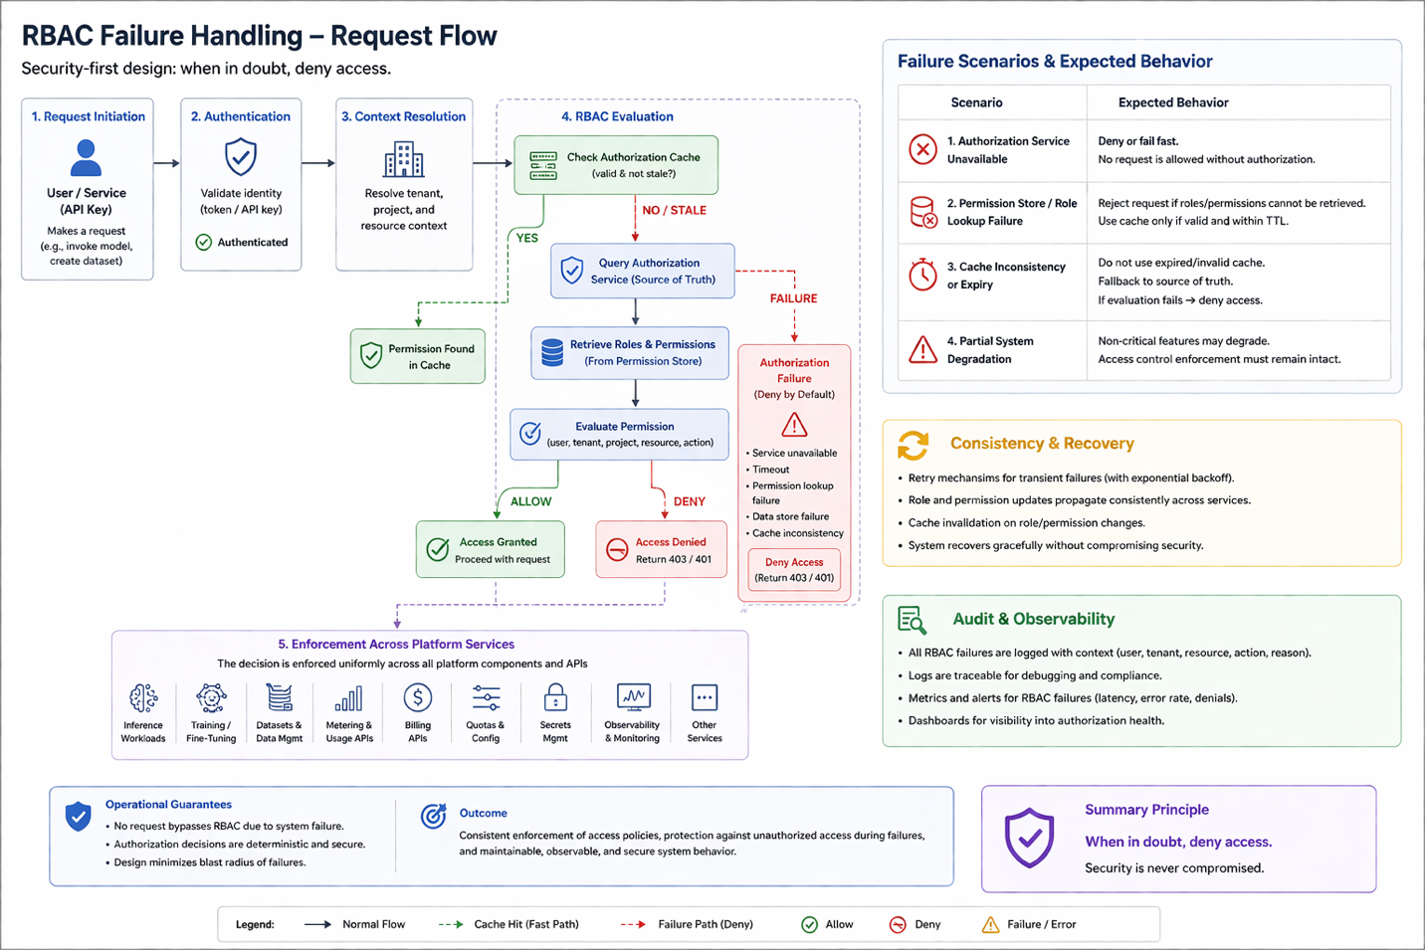

15. Success Criteria
- 100% request authorization
- zero cross-tenant violations
- full auditability
- low latency (< threshold)
- API-accessible RBAC enforcement

16. Summary
RBAC provides the security and control layer for the RACKAI platform, ensuring that every interaction with models, data, and platform capabilities is properly authorized, governed, and enforced.
It establishes a consistent framework for defining and enforcing access policies across all services, APIs, and workflows, enabling the platform to scale securely in a multi-tenant environment.
RBAC ensures:
- Secure multi-tenant operation
Access controls strictly enforce tenant boundaries, ensuring that users and services can only interact with resources within their own tenant, eliminating the risk of cross-tenant access or data exposure.
- Controlled resource access
Permissions are defined and enforced at multiple levels (tenant, project, resource), providing precise control over actions such as:
  - deploying and managing models
  - executing inference and training workloads
  - accessing datasets, usage data, and billing information
  - managing quotas, configurations, and secrets
- Compliance and auditability
All access decisions and permission changes are:
  - logged and traceable
  - auditable across users, services, and time
  - aligned with enterprise security and regulatory requirements

Operational Impact
With RBAC in place, the platform can:
- enable safe collaboration across teams within a tenant
- enforce least-privilege access at scale
- reduce risk of unauthorized access or misconfiguration
- provide consistent governance across all platform components
- support enterprise-grade security, compliance, and operational standards

Final Statement
RBAC ensures that every action in the platform is:
- authorized — only permitted users or services can perform it
- controlled — governed by clearly defined roles and permissions
- auditable — fully traceable for accountability and compliance
By embedding access control into every layer of the system, RBAC enables RACKAI to operate as a:
secure, governed, and enterprise-ready AI platform—where usage is not only measured and billed, but also trusted and controlled.

